EDI 830
Supplier Packet

Table of Contents:
- Introduction
- Understanding the Basics – Process Flow
- Inquiry - Questions to ask your IS/IT group
- Beyond the Basics – Understanding the 830
  - VMI Stream
    - Processing Kroger EDI830 Forecasts
    - Database /VMI Tool Setup
    - Review of Kroger EDI830 Forecasts
  - Enterprise Stream
    - Demand Planning Process
    - Sales Team Process
    - Supplier Example
- Glossary
- Most Commonly Exchanged EDI Documents
- Standard Format/Components of an EDI Document
- Kroger/Peyton Document
- Addendums
  - VMI Process Flow
  - Discrepancy Report

- Introduction
The following Supplier Packet was developed to help Suppliers understand the requirements for using the Kroger EDI 830 Shipment Forecast and how the EDI 830 Shipment Forecast can be used within their respective organizations.
This document will help the Supplier understand the basic requirements, how to communicate the requirements to their technical teams and how to incorporate this EDI transaction into their VMI and Enterprise Planning Process.
- What is the EDI 830
  - The transaction set can be used to provide for customary and established business practice relative to the transfer of forecasting information from Kroger to the Supplier.
- How can the Supplier use the EDI 830?
  - VMI Solution
    - The EDI 830 can be used to feed directly into the Supplier’s VMI/CRP Planning and Order System. It will provide the DC to Store forecast by week to help the Supplier plan and execute replenishment orders.
  - Enterprise Solution
    - The EDI 830 Forecast data can also be valuable to the Supplier even if it is not integrated into the VMI Planning and Order Systems.
  - Sales Solution
    - It can be used by your Sales teams to ensure that they are aligned with Kroger on their volume requirements for both baseline forecast and promotional volume.
      - However, the EDI 830 forecast does not include display forecasts.
      - The promotional forecast is only incorporated in the first 5 weeks of the forecast.
    - If there are differences discussions should take place so both organizations can understand and address the gap in the forecasted volume.
    - This will help both Kroger and the Supplier to ensure that they are driving efficiencies across the supply chain.

- Understanding the Basics - Process Flow

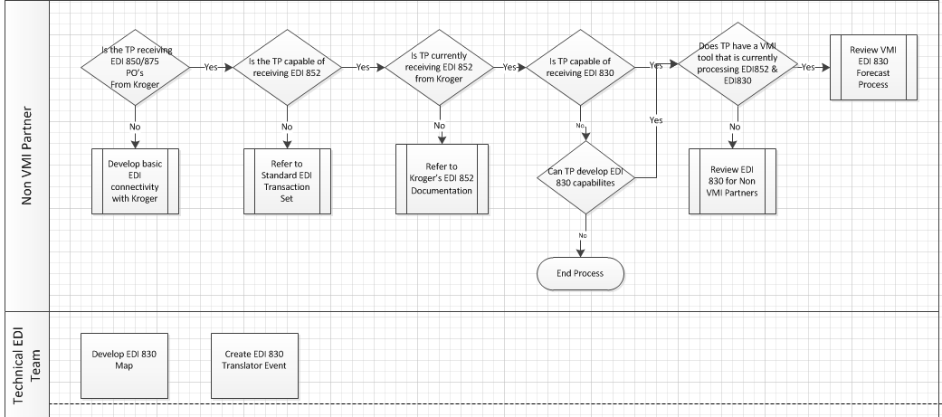
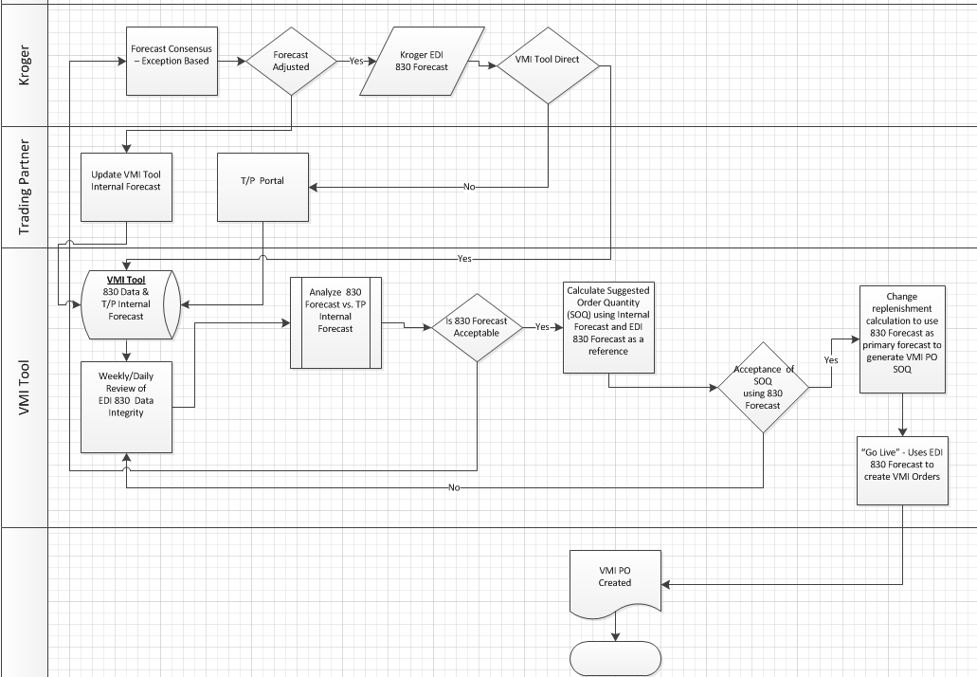

- Inquiry - Questions to ask your IS/IT group
Technical questions your Sales team might ask of your IT Dept.:
- Do we exchange EDI transactions with Kroger?
- What EDI transactions do we exchange with Kroger?
  - Examples:
    - EDI850 or EDI875 - Purchase Order
    - EDI810 or EDI880 - Invoice
    - EDI852 – Product Activity
    - EDI855 – Purchase Order Acknowledgment
    - EDI856 – Shipment Notice/Manifest
- What communication method is used?
  - The following communication methods are used by Kroger EDI:
    - AS2
    - VAN
      - If yes, who is your VAN?
        - If your VAN is different than Kroger’s, your VAN would make the necessary arrangements to interconnect to Kroger’s VAN
(Note: the assumption is whatever communication method is used for current EDI transactions, would also be used for the EDI830 transaction)
- What version of EDI transactions are we exchanging?
    - Kroger supports 005010
- What is our ISA ID and qualifier?
- What is our GS ID?
- Do we exchange FA’s (Functional Acknowledgments)?
- Do we exchange the EDI830 with anyone?
  - If yes, do we have a generic EDI830 map?
    - If yes, obtain Kroger’s EDI830 map located at:
http://edi.kroger.com/maps_kr/5010_830_082610.pdf
      - Compare Kroger’s map with your own map for specific differences.
  - If no, obtain Kroger’s EDI830 map (see link above) and use it to create your generic EDI830map

- Beyond the Basics – Utilizing the 830

Kroger/Peyton uses a forecasting tool that allows the supplier to receive via EDI a 13-week forecast of item movement for the Kroger Local DCs and a 17-week forecast of item movement for the Peyton Regional DCs. This information is communicated to the supplier in the EDI 830 transaction set. This tool utilizes key historical and promotional plan factors such as display, retail price, advertised and item seasonality to create an item forecast.
By sharing this valuable item information with our suppliers, Kroger is able to reduce total cycle time durations, increase service levels and improve accuracy throughout the entire supply chain. Kroger/Peyton Procurement works with selected suppliers to further improve the supply chain process, which creates a win-win for both our companies. Implementing the 830 transaction, results in a greater potential to improve in-stock position and increase sales and profits. **
**Note: - This is taken from the Kroger/Peyton Document which is in the addendum.
There are several ways to utilize the 830 and we will review two streams to show how Suppliers might use the EDI 830 transactions.
- VMI Stream
- Enterprise Stream

VMI Stream
PROCESSING KROGER EDI830 FORECASTS
Since each Supplier could conceivably use a different VMI tool, these suggested steps noted below are merely a high level overview of the possible actions to take that may or may not pertain to every Supplier/tool. The intention is to identify additional positions a Supplier might also need to consider.

DATABASE/VMI TOOL SETUP
- Activate any applicable enhancements that are related to the processing of the EDI830 data into the suppliers VMI tool.

- Apply the necessary settings/flags/indicators to allow the EDI830 data to populate the appropriate fields and receive processing messages within the Supplier’s VMI tool. This includes, but is not limited to:
  - Naming the source of external forecasts: “Kroger830”
    - The Supplier would apply an external forecast “source” name to all UPC’s for that particular Kroger Ship To warehouse

- The Supplier must decide if they intend to implement the EDI 830 forecast thru a phased-in approach by piloting a select group of items or all items at once
  - Depending on each Suppliers VMI tool’s capabilities, there could be multiple options available for utilizing the Kroger EDI830 forecasts:
  - OPTION #1 Point of Reference (suggested for initial setup and pilot period)
    - Visual check or cross reference to aide in replenishment decision process

  - OPTION #2 Replace 100% of the Suppliers VMI forecast with Kroger’s 830 forecast
    - Should be done only after validating accuracy of the forecasts from Kroger
    - This option uses Kroger forecasts to drive the replenishment requirements

  - OPTION #3 Blend a portion of the Supplier’s VMI forecasts with Kroger’s forecast
    - This option allows the Supplier to use a percentage of their VMI forecasts and a percentage of Kroger’s 830 forecast to create a blended forecast
    - Example: 30% VMI forecast + 70% of Kroger’s 830 forecast

Note: Any of these options noted above can be implemented at the SKU level; all SKU’s do not need to use the same option.

REVIEW OF KROGER EDI830 FORECASTS
Assuming the Suppliers VMI forecasts are accurate, the Supplier would now compare their VMI forecasts against Kroger 830 forecasts to ensure the Kroger 830 forecasts are acceptable.

- Ensure all applicable items are accounted for and do indeed have a forecast or understand why there is not a forecast. It is imperative that Kroger item codes and forecasts are aligned with the Supplier’s item codes and forecasts regardless of the item’s activity status.
- Active, New, Linked (special packaging that replaces existing Item), Inactive, and Discontinued
- ‘In and Out’ or ‘One Time Buy’ items typically do not have a regular turn forecast since they are not replenished thru regular ordering patterns.

- Determine an external forecast maintenance review schedule to identify any large discrepancies.
(Suggestion would be to review external forecasts on any day that Kroger sends an updated EDI830 file. Remember, even though Kroger is sending a forecast, it is still every Supplier’s responsibility to make sure the forecasts from Kroger are accurate).
Kroger EDI 830 Forecast Transmission Schedule:
Full load – Every Monday a.m.
Changes only – The next day after they are made in Kroger’s system
Peyton’s EDI 830 Forecast Transmission Schedule:
Full load – Every Monday a.m.
Changes only – Not applicable

- Set a Forecast Error Tolerance % level to identify forecasts that need attention.

- Design a “Kroger EDI830 Forecast Discrepancy Report” which would be used to extract the items with the forecasts that exceed the Tolerance % into an Excel spreadsheet for further analysis.
  - (See Addendum ‘B’)
  - Suggested field to include on the ‘Kroger EDI830 Forecast Discrepancy Report’ is a “Reason Code” which can be used to track trends…..i.e.
    - New items continue to be a challenge, etc.
  - If there is a large gap between Kroger 830 forecast values and the Supplier’s forecast values, the Supplier must have a process in place to address and resolve those forecast discrepancies immediately.
    - Action items to address gaps (See suggested questions to consider below)
      - Determine an acceptable window of time to resolve the discrepancies
    - Confirm any items needing unit of measure conversions are identified and addressed.

- Lead-time constraints must be agreed upon between Kroger and Supplier
- Forecast changes that are received after the lead-time window is past would be disregarded due to the fact that orders have already been written.
- Validate Supplier’s system capabilities can identify Kroger 830 forecast changes that fall outside normal order dates (Some Suppliers VMI tool could have the ability to generate an error message alerting the Supplier of these instances)
- In the event of an out of stock due to lead-time constraints, the Kroger buyer should contact the Suppliers VMI Specialist to place a special order; this is outside the normal VMI process.

- Questions to consider while reviewing the “Kroger EDI830 Forecast Discrepancy Report”:
Q: Is the UPC code a valid material that can be ordered? (Some Suppliers VMI tool will generate an error message if an item is not currently setup for that particular Kroger Ship To location. This error message is the notification to research the material to determine if it is indeed a valid item that can be ordered and should be forecasted by Kroger)?
Q: Why is the Kroger/Suppliers VMI forecast so high?
Q: Why is the Kroger/Suppliers VMI forecast so low?
Q: Why is the Kroger/Suppliers VMI forecast missing?
Q: Why is the Kroger/Suppliers VMI forecast at zero?
Q: Does the Kroger forecast include promotional demand?

- Identify a share point location accessible by all Supplier VMI Specialists that can be used to house the “Kroger EDI830 Forecast Discrepancy Report” for additional follow-up and future reference

- Communication Protocol
- Phase 1 – Start-Up
- It is critical that the Supplier and Kroger discuss all forecast discrepancies and or master data issues in order to find the root cause for the discrepancies before moving forward in the process.
- Phase 2 –
- Establish a regularly scheduled meeting to ensure both the Suppliers commercial/sales team and Kroger’s forecasting team are aligned on the forecasted volume.
- Frequency can be determined as deemed necessary for each individual business.

- Once the Supplier is satisfied with Kroger 830 forecasts and feels comfortable with their quantities, the Supplier can implement the EDI830 forecast for all items using Option #2 or the Supplier may continue to use the Kroger EDI830 forecast as an additional point of reference using Option #1.

Kroger EDI830 Forecast Discrepancy Report – Example

Enterprise Stream
General Comments:
If the Supplier does not have the capabilities or does not currently participate in a VMI program with Kroger there is still value to receiving the EDI 830 transaction as an input to the Demand Planning Process or into the Sales Process.
Vendors may choose to utilize the 830 data as a tool to assist in creating their sales forecast or production plan. The forecast can be generated at the Item/National or the Item/DC level.
The 830 document can be combined with the Vendor’s resources and other tools to assist in creating an end result.
Demand Planning Process
- Most suppliers have a demand planning group which is responsible for generating a demand forecast that is used by their Supply Planning team.
- This forecast can be generated at an Item/National, Item/Customer and Item/DC level.
- The EDI 830 can be a direct feed into their process or the Demand Planner may elect to use it as a secondary input to their process as they develop their final demand plan.
- This can be complicated and drives many supply chain decisions so it will be important to validate the data and ensure that the feed is acceptable before signing off on your final demand plan that goes to the Supply Planning teams.
- Each Supplier will need to determine what is best for their organization based on human resources, system capabilities and the scale of the business.
- It now gives the Supplier the ability to reconcile their internal forecast with the Suppliers Demand Planning team and/or the Sales team.
Sales Team Process
- In the event that the EDI 830 is not used in the Demand Planning Process the data should be used to ensure that Kroger and the Suppliers Sales teams are aligned.
- The data should be assembled into a format that can easily be used by the Sales Team to reconcile against their internal forecasts, sales plans and/or promotional events.
- The Sales team, depending on the business, might choose to only review promotional data if there is confidence in the base line forecast.
- Each Supplier will need to review the data in order to determine which method should be used in their process.
- What is most important is that there is now the ability to reconcile and achieve alignment between the Supplier and Kroger in order to achieve a high on shelf availability measure

Note: Both of these processes will provide opportunities for communication with the Kroger Merchandising and Inventory & Replenishment teams in order to ensure that both the Supplier and Kroger are aligned on the forecast. This ensures that not only is the base forecast accurate but all promotional events are reconciled both in quantity and timing. Display and bonus items are not transmitted on the 830 transaction. The bonus item shipments are combined with the corresponding base item shipments to transmit in a single forecast for the base item.

Supplier Example: Sales Account Team and Supply Chain Alignment
Sales Account Team:
One of the Suppliers that was interviewed has elected to use the EDI 830 as a feed to the Sales Account Teams.
- This Supplier develops the final demand plan using two main sources, input from the Sales Account Team and a statistical model generated by the Supply Chain Demand Planning Team.
- The first source of data is an input into a tool by the Sales Account Team.
  - They are responsible for developing a $/Case forecast by segment (usually a group of products within the same price group)
  - The Sales Account Team understands the historical trends and is also very close to the promotional activity with the customer.
  - This Sales Account Team is responsible for generating this forecast and is held accountable to that number at the end of the month.
- The EDI 830 can now be used to reconcile against what they thought was going to happen for the baseline and promotional activity.
- If there are any differences in the numbers, the Sales Account Team and the Customer will need to discuss to understand why they are not aligned.
- Once the number is agreed upon the Sales Account Team and or Kroger can finalize their forecast and pass that along to the Supply Chain Demand Planning Team.
Supply Chain Demand Planning Team:
- The Demand Planning team is also responsible for developing a forecast at the segment level using 3 years of historical data. The Demand Planning Team will use the input from the Sales Team as well as the data that is developed out of the statistical model to develop the demand plan.
- The Demand Planning team is responsible for meeting with each Account Team (Mainly the larger customers) on a monthly basis or more often if necessary in order to ensure that the demand plan and the Sales Account Teams forecast are aligned.
- This monthly process helps ensure that the Supply Chain Planning Teams are working from one consensus number in order to ensure supply.
- It is important to note that the EDI 830 shipment forecast is a weekly rolling 13 weeks of data for Kroger Local DCs and 17 weeks of data for Regional (Peyton) DCs.
- This forecast should be review weekly to identify any changes.
- This Supplier has elected to only review the next 4-6 weeks of forecast.
- Again, this is an individual Supplier decision based on your manufacturing capabilities and cycle times.

- GLOSSARY:
ANSI (American National Standards Institute) = A designated accredited standards committee for EDI and are still the most commonly used standards in North America.

AS2 (Applicability Statement 2) = A specification about how to transport data securely and reliably over the Internet. Security is achieved by using digital certificates and encryption.

ASN (Advanced Shipment Notice) = An EDI transaction that tells the customer all the details about a shipment: what items were sent, how many, when they were sent, etc.

DIRECT = see POINT TO POINT

D-U-N-S (Data Universal Numbering System) = A unique nine-digit number, issued by Dunn & Bradstreet, used to identify each business and distinct operation in the D&B database.

D-U-N-S+4 = The DUNS number plus a 4-character alpha/numeric/or combination suffix that may be assigned at the discretion of a company to establish additional identifying information.

EDI (Electronic Data Interchange) = the “computer-to-computer” communication of business documents between companies in a standardized format.

FA (Functional Acknowledgment) = An EDI transaction that confirms an EDI transaction set has been received by a trading partner and indicates the time and date of receipt. It does not imply acceptance of the contents of the associated transaction sets.

FTP (File Transfer Protocol) = A standard network protocol used to transfer computer files between a client and server on a computer network. It is built on a client-server model architecture and uses separate control and data connections between the client and the server

GS ID’s = Functional Group Header ID’s used at the beginning of a group of transaction sets and provides a second level of Sender and Receiver IDs. ISA ID’s would be the primary level of ID’s.

ISA ID’s = Interchange Communications Identifiers used to identify the Sender and Receivers of each EDI envelope. GS ID’s would be the secondary level of ID’s.

INTER-CONNECT = Two VAN’s who link to one another’s address.

MAPPING = The act of determining what pieces of information in a company’s database should be placed into each data element of an EDI message or transaction set, or in reverse, what data elements of an EDI message or transaction set should be placed into the company’s database

POINT TO POINT = A type of communication whereby messages are sent directly from one trading partner to another without the use of a VAN.

T/P (TRADING PARTNER) = another company with whom you conduct business, such as a Supplier or customer.

UCS (Uniform Communication Standard) = Standards used by the grocery industry and other retail-oriented industry sectors and are a subset of the ANSI ASC X12 standards.

VAN (Value Added Network) = A hosted service offering that acts as an intermediary between business partners sharing standards based proprietary data via shared business processes.

VMI (Supplier Managed Inventory) = A system of inventory replenishment in which the Supplier accepts responsibility for maintaining their customer’s inventory levels of the Supplier’s products by monitoring inventory information sent by the customer. Often referred to as “CRP” (Continuous Replenishment Planning)

- Most Commonly Exchanged EDI Documents
INVOICE: ANSI = EDI810 UCS = EDI880
Issued by the trading partner who has provided products and/or services as a request for payment. EDI invoices include most of the purchase order information as well as Invoice Number, Invoice Date and Total Amount Due.

PURCHASE ORDER: ANSI = EDI850 UCS = EDI875
Order details from a customer that includes the items, quantities, actual or estimated cost, Terms, Notes, Ship-to locations, Ship Dates, Cancel Dates, etc.

PRODUCT ACTIVITY: EDI 852
Used to provide trading partners with SKU activity data, such as inventory levels, sales movement and other activity-related information at the distribution center or individual store location level.

PURCHASE ORDER ACKNOWLEDGMENT: EDI 855
Used to provide seller's acknowledgment and acceptance or rejection of a buyer's purchase order. This can be an acknowledgement that the entire ordered quantity will be shipped and the date when it will be shipped. It can also be a line by line acknowledgment of partial or complete quantities and single or multiple shipping dates.

ADVANCE SHIPPING NOTICE: EDI856
Used to tell the customer all the details about a shipment: what items were sent, how many, when they were sent, etc. It has information about each carton and its contents including the carton number, weight, cube, etc.

FUNCTIONAL ACKNOWLEDGMENT: EDI 997
Used to indicate that a transmission was received by a trading partner, but does not indicate agreement with the document.

SHIPMENT FORECAST: EDI 830
Planning Schedule transaction set is essentially an electronic sales forecast. The transaction set can be used to provide for customary and established business practice relative to the transfer of forecasting/material release information between organizations.

- Standard Format/Components of an EDI Document
EDI Transaction Structure
A single EDI transmission constitutes the following components:

ISA/IEA Envelope
- This envelope isolates one group of transmitted data from another. Each envelope contains EDI documents to (outbound) or from (inbound) a single EDI trading partner.
GS/GE Envelope
- These envelopes contain one or more documents of the same type. The use of separate GS/GE envelopes allows for several different document types to be communicated within the same ISA/IEA envelope.
ST/SE Envelope
- These envelopes isolate one document from another within the GS/GE envelope.
A Transaction Set is wrapped in the Transaction Set Header/Trailer (ST/SE) envelope.
Data Segment
- Similar to a record in a data file, Data Segments are used to make up Transaction Sets. Data Segments are roughly equivalent to a single line on a document.
Data Element
- Similar to a field in a record, data elements contain the basic units of information and are used in various combinations to make up Data Segments.

The Interchange Header (ISA), commonly known as the Communications envelope, starts an interchange of one or more functional groups. It contains: the syntax identifier, Sender and Receiver EDI ID's, unique control number, acknowledgment requested, test indicator, date and time sent, recipient reference or password, and version of Standard being used.

The Functional Group Header (GS) indicates the beginning of a group of transaction sets and provides a second level of Sender and Receiver IDs. It usually includes an identifier for the type of transaction set, application sender identifier, application recipient identifier, date and time sent, unique functional group reference, agency responsible for specification of structure (i.e. X12, VICS), message type version, and password.

The Detail area contains the details of the business transaction. In a PO document, the ST includes elements such as: Purchase Order Number, Date and PO Type, Item Numbers for Products Ordered and Product Descriptions, Prices, Method of Shipment and Delivery Dates, Terms of the Order, and, for some orders, a Distribution List by Item by Location.

The Trailer Envelope Segments contain control information such as total ST Segments and total GS Segments and unique control numbers that must be identical to the values in the ISA and the GS.

For more information on Kroger EDI mapping guidelines, please visit:

http://edi.kroger.com/maps_001.htm

- Kroger/Peyton Document

830 Planning Schedule with Release Capability
Kroger & Peyton

INTRODUCTION to 830’s – ITEM FORECASTING DATA

Kroger/Peyton uses a forecasting tool that allows the supplier to receive via EDI a 13-week forecast of item movement for the Kroger Local DCs and a 17-week forecast of item movement for the Peyton Regional DCs. This information is communicated to the supplier in the EDI 830 transaction set. This tool utilizes key historical and promotional plan factors such as display, retail price, advertised and item seasonality to create an item forecast.
By sharing this valuable item information with our suppliers, Kroger is able to reduce total cycle time durations, increase service levels and improve accuracy throughout the entire supply chain. Kroger/Peyton Procurement works with selected suppliers to further improve the supply chain process, which creates a win-win for both our companies. Implementing the 830 transaction, results in a greater potential to improve in-stock position and increase sales and profits.

830 Transmission Schedule:

- For the Peyton Regional DCs, the EDI 830 transmits every Monday.
- For all other Kroger Local DCs, the EDI 830 transmits every Monday and possibly other days of the week.
- The Monday morning 830 transmission contains all items for all EDI 830 suppliers. However, for other days, only the items whose forecast changed in the Kroger/OLP Procurement System will transmit via EDI to the suppliers. The 830 transmission from the Peyton / ChainStore Procurement System for the Peyton Regional DCs only transmits Mondays.

830 Forecast Values:

Item forecasts are the value held in the Kroger/Peyton Procurement System(s) at the time of the 830 transmission.

- If a Kroger Buyer changes a forecast, the supplier will see the change in the next day’s 830 transmission.
- If a Peyton Buyer changes a forecast, the supplier will see the change on the next Monday’s 830 transmission.

Display and Bonus Items:

Display and bonus items are not transmitted on the 830 transaction. The bonus item shipments are combined with the corresponding base item shipments to transmit in a single forecast for the base item.
Unit of Measure and Quantity Sent on the 830:
- On the Peyton Regional DC 830 Forecasts, items shipped to the stores in sleeves or inner pack quantities, list EA (Each) as the unit of measure and quantity. At the same time, items shipped to the stores in full cases, list CA (Case) as the unit of measure and quantity.
- On the Kroger Local DC 830 Forecasts, CA (Cases) is transmitted as the unit of measure and quantity. The forecasted case quantity for items in the Kroger Local DC is always rounded up to the next case.

Steps to setup the 830 Transmission:

- Supplier obtains approval from the Kroger Procurement Group to begin the 830 relationship.
- Supplier provides the following information to the Kroger Procurement Group:
  - Supplier Name and Number
  - Kroger Distribution Center
  - Trading Partner Name and ISA ID/Qualifier
  - Start Date
  - Contact Information
- Supplier confirms with EDI@Kroger.com the Trading Partner ISA ID is set up in the Kroger EDI Partner file.
- Corporate Procurement sets the 830 flags on the purchasing system.
- Kroger EDI cross-references the JIT # listed on the Corporate Procurement system to the Supplier’s EDI partner setup on the Kroger EDI Gentran system

Procurement - JIT# (Just in Time #):

- A JIT# is used to cross reference the Supplier’s forecast to the EDI trading partner. The JIT # listed in the Kroger procurement system for the trading partner must be cross referenced to the trading partner’s ISA id in Kroger EDI.

- If the supplier receives the 852 Activity Data from Kroger, they are already set up with a JIT# in ChainStore (Peyton Regional DC Procurement System) and OLP (Kroger Local DC Procurement System) and the JIT # is cross-reference to their ISA ID on EDI Gentran.
- The Supplier and Procurement need to confirm the relationship, ISA ID, JIT#, JIT# cross-reference and set the flags in the Kroger/Peyton Procurement System(s). Once the 830’s are sent, the Supplier should confirm with Procurement the first transmission was received.

830 Transaction Map:

LIN Item Identification Segment

- On the EDI830, UPC case code items are identified with a “UA” Qualifier. GTIN items are identified with a “UK” qualifier.
- In addition, the Purchaser’s item codes (Peyton Line Number or Kroger Line Number) are identified with a “PI” qualifier.

FST Forecast Schedule segment:

- The total of SDQ (total forecast quantity for all weeks)
- The forecast start date (Sunday)
- The forecast end date

SDQ Destination Quantity segment:

- Unit of measure
- Facility D-U-N-S + 4
- 17 week forecast on each Item (Peyton Regional DCs)
13 week forecast on each Item (Kroger Local DCs)

For further information, please review the 830 map on the following URL: http://edi.kroger.com/maps_kr_001.htm

- Addendums

Addendum A – VMI Process Flow

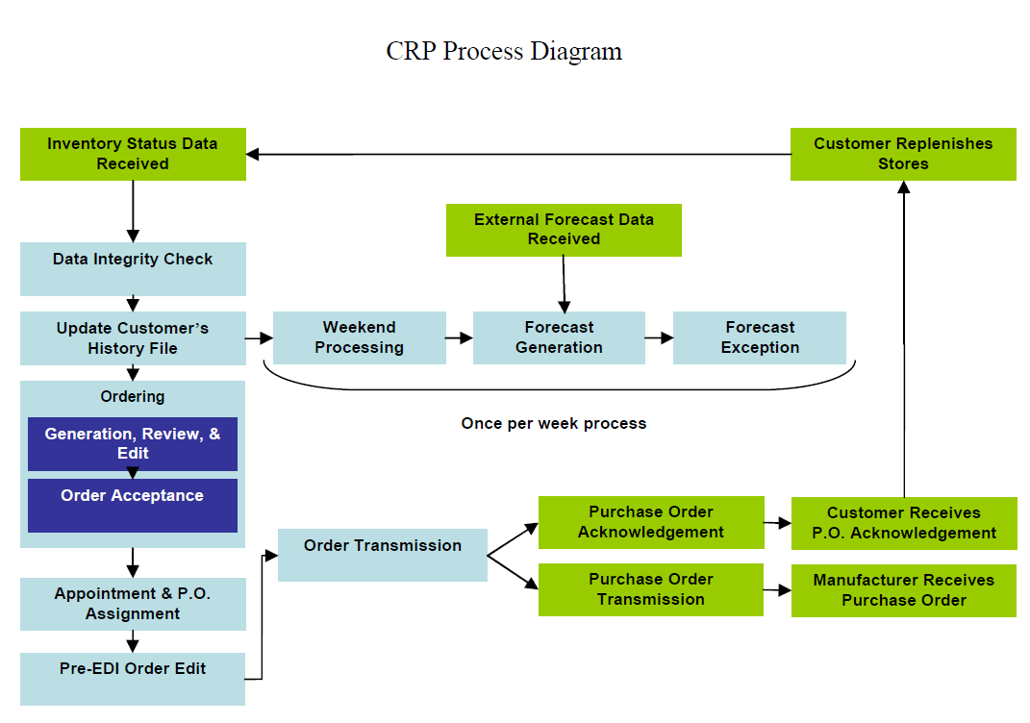

Addendum B – Discrepancy Report

